Date of planning:  Date of teaching: | UNIT 9: FUTURE TRANSPORT  Period 97: Grammar 2
I. OBJECTIVES:
By the end of the lesson, Ss will be able to:
* Vocabulary:
* Grammar:
- Use as … as and different from to compare means of transport.
1. Competence: Understand the main grammatical points, then do the tasks assigned in the textbook. Use as … as and different from to compare different means of transport in Vietnam and other countries.
2. Quality/ behavior: To teach Ss to be hard-working and attentive in class. Ss have a positive attitude to working in groups, individual work, pair work, cooperative learning and working.
II. TEACHING AIDS:
- Teacher: Grade 7 textbook, Unit 9 (SB p.94), laptop/computer connected to the Internet, loudspeaker, projector/TV, PPT slides…
- Students: Text books, studying equipment…
- Method: Active teach, T-WC; group works; individual ……
III. PROCEDURE:

1. WARM UP (5’)
* Aim:
- To create a positive classroom atmosphere to start a new lesson.
- To lead into the new lesson.
* Organisation: T-Ss, Ss-Ss, Group work.
Teacher’s & Student’s activities |  | Content
Extra activity 1: Comparison game.  - T prepares a collection of things for Ss to compare.  - T explains the game rules then checks instructions.  - T elicits the words ‘similarity’ and ‘difference’, writes these two words at the top of the board and draws a vertical line between them.  - T elicits the similarities and differences between ‘a pen’ and ‘a pencil’ as an example.  - T tells Ss that, today they will learn about as … as and different from to compare different means of transport. |  | Game rules:  - Ss work in groups of three.  - Each group works with one pair of things.  - Ss write down as many similarities and differences as possible.  - T sets time limitation of 2 or 3 minutes  - Groups crosscheck each other, Ss can edit and add more information.  - Each reasonable similarity/ difference = 1 point.
2. LEAD-IN (6’)
ACTIVITY 1
*Aim:
- To set the context for the new grammar point.
* Organisation: T-Ss, Ss-T.
Teacher’s & Student’s activities | Content
1. Look at the photos. Which flying car do you like more, the red or the yellow one?  (Ex 1 – SB p.94)  - T asks Ss to look at the photos and circle the red and the yellow flying cars in the picture.  - T asks Ss to choose which flying car do they like more, the red or the yellow one.  - T calls some Ss to share which one they choose and explain their choice. | 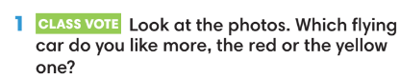
3. PRESENTATION (10’)
ACTIVITY 2:
*Aim:
- To present the grammar point in context.
- To introduce the Grammar Notes and explain the grammar point.
* Organisation: T-Ss, Ss-T.
Teacher’s & Student’s activities | Content
2. Read and listen. Underline examples of the as … as and different from in the dialogue.  (Ex 2 – SB p.64)  - T tells S to read the Grammar box and elicits the usage of as… as and different from.  - T asks Ss to listen and read the dialogue and underline all examples of the as … as and different from.  - T asks some Ss to read out loud sentences with as … as and different from, checks their pronunciation if necessary.  - T asks Ss to write down the sentences from the dialogue that use the patterns. Then, have them create their own sentences by keeping the patterns and changing just one or two words.  - Ss exchange sentences with a partner, then change the partner’s sentences even further by changing two or three more words.  - Ss return sentences to their partner and read their new sentences.  - T invites some Ss to share their new sentences with the whole class. | 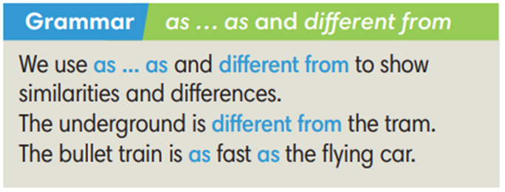
4. PRACTICE (11’)
ACTIVITY 3:
* Aims:
- To help Ss practice making sentences with as … as and different from.
* Organisation: T-Ss, Ss-T, Ss-Ss, Individually, Pair work
Teacher’s & Student’s activities | Content
3. (5’) Write sentences using (not) as … as … comparing the two vehicles below.  (Ex 3 – SB p.94)  - T calls a S to read the instruction then checks Ss’ understanding.  - T asks Ss to do Exercise 3 individually before comparing their answers in pairs.  - T invites Ss to give their answers and checks answers with the whole class. | Answer keys:  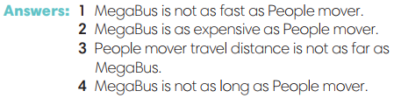
(6’) Extra activity 2: Game – Hot potato.  - T explains the game rules then checks instructions.  - T checks the sentences with the whole class. | Game rules:  ✔ T plays music and Ss pass a ball to each other in the whole class.  ✔ When the music stops, the S has the ball needs to make a sentence with either as … as or different from to compare people and things in the class.  ✔ 1 correct sentence = 1 point.
5. PRODUCTION (10’)
ACTIVITY 4:
* Aims: To help Ss applying the vocabulary items and grammar points related to the topic in communicating..
* Organisation: T-Ss, Ss-Ss, Pair work.
Teacher’s & Student’s activities | Content
4. In pairs, ask and answer about different means of transport in Vietnam. Use as … as and different from and some of the adjectives below.  (Ex 4 – SB p.94)  - T asks Ss to look at exercise 4 (SB page 94).  - T calls a S to read the instructions.  - T goes over the vocabulary to make sure Ss understand it.  - T asks Ss to make example sentences for each of the adjectives in the Vocabulary box and asks them to find its antonym.  - T elicits different means of transport in Việt Nam and writes on the board.  - T puts Ss into pairs to ask and answer about different means of transport in Việt Nam.  - T reminds Ss to use as … as and different from and the given adjectives.  - T asks a good pair to model the activity in front of the class.  - T walks around to note down any mistakes for later feedback.  - T invites some pairs to practise asking and answering in front of the class and asks the other Ss to give comments on their classmates’ performance. | 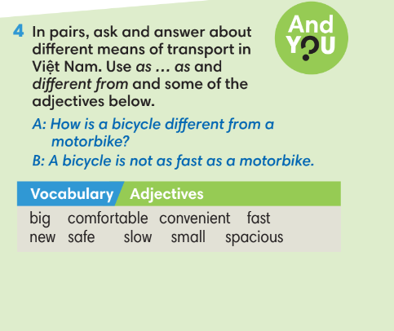
WRAP-UP & HOME WORK (3’)
- T asks Ss to talk about what they have learnt in the lesson.
✔ Use as … as and different from to compare different means of transport.
* HOME WORK
- Do exercises in the workbook page 81.
- Prepare for Lesson 9.5: Listening and vocabulary.

