Date of planning:  Date of teaching: | UNIT 9: FUTURE TRANSPORT  Period 98: Listening and Vocabulary
I. OBJECTIVES:
By the end of the lesson, Ss will be able to gain:
Vocabulary: an understanding of the vocabulary about traffic problems.
* Grammar:
1. Competence: Know the meaning of the keywords used to talk about traffic problems and discuss some solutions. Do the tasks assigned in the textbook. Listen and identify general and specific details in a recording about traffic problems.
2. Quality/ behavior: To teach Ss to be hard-working and attentive in class. Ss have a positive attitude to working in groups, individual work, pair work, cooperative learning and working.
II. TEACHING AIDS:
- Teacher: Grade 7 textbook, Unit 9 (SB p.95, WB p.82), laptop/computer connected to the Internet, loudspeaker, projector/TV, PPT slides …
- Students: Text books, studying equipment …
- Method: Active teach, T-WC; group works; individual …
III. PROCEDURE:
1. WARM UP + LEAD-IN (10’)
* Aims:
- To review grammar points from the previous lesson and get students involved in the lesson.
* Organisation: T-Ss, Group work.
Teacher’s & Student’s activities | Content
Extra activity 1: Game – Comparison sentence race.
- T shows on the slide 2 pictures of the busy traffic in Hà Nội and the little or no traffic in a province.
- T asks Ss to compare these two places using as … as and different from.
- T divides the class into 3 teams.
- T sets time limitations of 2-3 minutes.
- Three teams race to write comparing sentences on the board.
- Each correct sentence = 2 points.
- T checks all comparing sentences on the board with the whole class and gives feedback.
- T sets the scene for the new lesson: T tells Ss that they are going to learn how to listen for main ideas and specific details about traffic problems, and later on talk about traffic problems.
- T writes the title on the board Unit 9: Future transport
Lesson 9.5: Listening and Vocabulary
2. PRE-LISTENING (5’)
ACTIVITY 1:
*Aims:
- To lead into the topic.
* Organisation: T-Ss, Ss-T, Pair work
Teacher’s & Student’s activities | Content
1. Look at the picture. Where do you think this is? What is causing it?  (Ex 1 – SB p.95)  - T asks Ss to look at the pictures and tell where it is and how they know that.  - T gives Ss a quick scenario about when T got stuck in traffic.  - T asks Ss to work in pairs and discuss the possible causes of these traffic problems.  - T invites some volunteers to share their group’s discussion and notes down some causes on the board. | 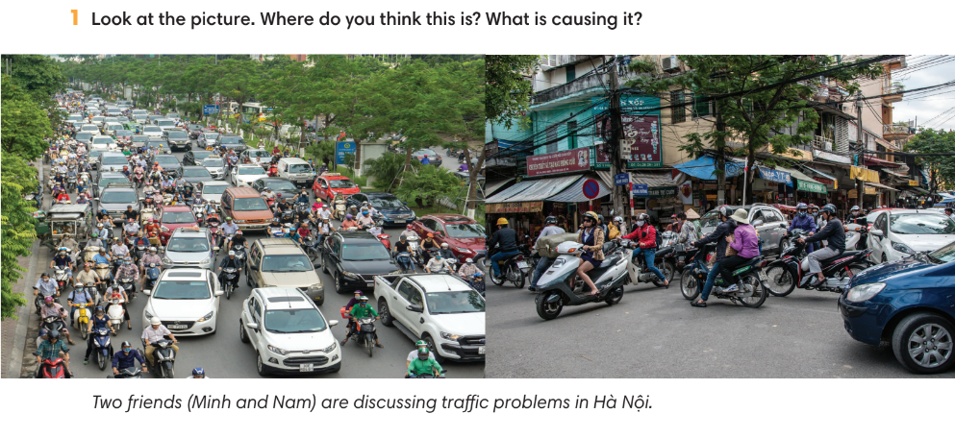
3. WHILE-LISTENING (15’)
ACTIVITIES 2, 3 & 4:
* Aims:
- To help Ss identify main ideas of the recording.
- To help Ss identify specific details in the recording.
- To introduce new words in context.
* Organisation: T-Ss, Ss-T.
Teacher’s & Student’s activities | Content
2. (5’) Lisen and tick the topics that are mentioned in the recording.  (Ex 2 – SB p.95)  - T asks Ss to look at Exercise 2 on SB p.95, to read the instruction and all items in Exercise 2.  - T goes through each item in Exercise 2 to make sure Ss know their meanings.  - T lets Ss listen once to the recording and complete Exercise 2.  - T elicits Ss’ answers on the board.  - T plays the audio again and checks the answers with the whole class.  - T encourages Ss to give the evidence that they hear from the audio track to prove their answers. | Answer keys:  Tick: 1, 2, 3, 4, 5, 7
3. (5’) Listen to the recording again. Mark the sentences (right), (wrong), ? (doesn’t say).  (Ex 3 – SB p.95)  - T asks Ss to read instructions and all sentences then underline any key words in the statements, and make guesses from their memory of the first listening by marking the sentences right, wrong or doesn’t say.  - T plays the recording again to let Ss do Exercise 3.  - T elicits Ss’ answers on the board. | Answer keys:
4. (5’) Listen again. Tick () the phrases you hear in the recording.  (Ex 4 – SB p.95)  - T asks Ss to do Exercise 4 using their memory of the recording.  - T plays the recording again to let Ss check their answer.  - T elicits Ss’ answers on the board then check the correct answers to all Exercise 2, 3 and 4 with the whole class.  - T asks Ss to give evidence for the answers from the recording.  - T explains the meaning of Word friends if needed and asks Ss to make sentences with word friends list. | Answer keys:  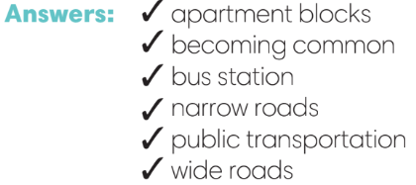
4. POST-LISTENING (12’)
ACTIVITY 5:
*Aims:
- To reinforce word friends.
- To practise using new words in context.
* Organisation: T-Ss, Pair work.
Teacher’s & Student’s activities | Content
(6’) Quiz, Quiz, Trade game.  - T selects a set of task cards for the activity. Task cards with word friend list, multiple choice or concrete short answer questions about different means of transports and traffic problems.  - T explains the game rules then checks the instruction.  - T models the activity with one volunteer and makes sure Ss know the rules. | Game rules:  - Each S is given a task card.  - Ss work in pairs: Partner 1 asks Partner 2 his/her question, Partner 2 answers, then Partner 1 acknowledges a correct answer or give the answer if needed.  - The process reverses with Partner 2 asking the questions.  - After both questions have been asked, while music plays, the partners switch cards, find new partners and the process begins again when the music stops.
5. (6’) In pairs, read the following solutions and tick the ones you agree with. Then compare your answers.  (Ex 5 – SB p.95)  - T asks Ss to read the instructions and all solutions.  - Ss work in pairs to discuss the given solutions.  - T reminds Ss to you the structure I think we should … to express their opinion.  - T walks around to provide feedback.  - T asks some good pairs to model the discussion. | 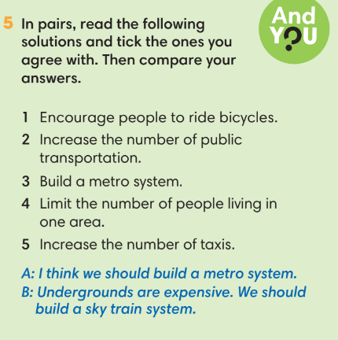
WRAP-UP & HOME WORK (3’)
- T asks Ss to talk about what they have learnt in the lesson.
- Listen for main ideas and specific details about traffic problems.
- Discuss some solutions for traffic problems.

* HOME WORK
- Do exercises in the workbook page 82.
- Prepare for Lesson 9.6: Speaking.

=====================

