Date of planning:  Date of teaching: | UNIT 9: SCHOOLS  Period 99: Revision
I. OBJECTIVES:
By the end of the lesson, students will be able to:
- Use the vocabulary and grammar of the unit to talk about different means of transport: - will / will not,- as … as, different from
- Practise writing a paragraph about the advantages and disadvantage of a means of transport.
1. Competence: Understand and use vocabulary to talk about different means of transport.
2. Quality/ behavior: To teach Ss to be hard-working and attentive in class. Ss have a positive attitude to working in groups, individual work, pair work, cooperative learning, and working.
II. TEACHING AIDS:
- Teacher: Grade 7 textbook, Unit 9 (SB p.99), laptop/computer connected to the Internet, loudspeaker, projector/TV, PPT slides …
- Students: Text books, studying equipment….
- Method: Active teach, T-WC; group works; individual ……
III. PROCEDURE:

1. WARM UP & INTRODUCTION (8’)
*Aims:
* Aim: To help Ss review the vocabulary learnt in the unit.
* Content: Vocabulary of the unit.
* Outcome: Review the vocabulary.
* Organisation: T’s instruction.
Teacher’s & Student’s activities |  | Content
(4’) Extra activity 1: Quiz, quiz, trade game.  - T prepares a set of word cards.  - T explains the game rules then checks the instruction.  - T models the activity with a volunteer S.  - T can play music while Ss are playing, and pause the music to stop the activity.  - T walks around to help Ss and notes any difficulties/challenges for later feedback. |  | Game rules:  ✔ Each S is given a word card.  ✔ Ss work with partners to explain the word for their partners to guess the word.  ✔ Once both Ss in a pair finish describing their word, they exchange their word card and find another partner to continue.
(4’) Extra activity 2: Creative sentence making.
- T writes three random words of different forms on the board and asks Ss to identify their word forms.
- T asks Ss to make a sentence containing these 3 words individually before sharing with a partner.
- T walks around the class and notes any difficulties/ mistakes for later feedback.
- T asks some Ss to read out their sentences and asks their classmates to give peer feedback.
2. PRACTICE (13’) – VOCABULARY
ACTIVITIES 1, 2, 3:
*Aim:
- To review vocabulary in context.
* Content: Vocabulary learnt in the unit.
* Outcome: To clearly understand the learnt vocabulary and use them correctly in the context.
* Organisation: T’s instruction.
Teacher’s & Student’s activities | Content
1. (5’) Choose the odd one out. Explain why.  (Ex 1 – SB p.99)  - T asks Ss to open their SB page 99, look at exercise 1.  - T calls a S to read the instruction then checks Ss’ understanding.  - T asks Ss to work in pairs to do exercise 1.  - T calls some Ss to give answers and checks the answers with the whole class. | Answer keys:  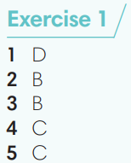
2. (4’) Use the word below to complete the phrases.  (Ex 2 – SB p.99)  - T calls a S to read the instruction then checks Ss’ understanding.  - T asks Ss to do the exercise individually before checking their answers with a partner.  - T checks the answers with the whole class.  - T asks Ss to write a sentence for each phrase to describe it.  - When S have finished, ask a S to read out one of their sentences so the other Ss can guess which phrase the description is for. | Answer keys:  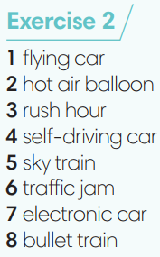
3. (4’) Complete the sentences with one word.  (Ex 3 – SB p.99)  - T asks Ss to do the exercise individually before checking their answers with a partner.  - T calls some Ss to read their answers and corrects if needed. | Answer keys:  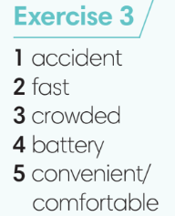
3. PRACTICE (13’) GRAMMAR
ACTIVITIES 4 & 5:
* Aim: To review the grammar points learnt in the unit.
* Content: Texts about different means of transport.
* Outcome: To review will / will not, as … as, different from and use them correctly in sentences.
* Organisation: T’s instruction.
Teacher’s & Student’s activities | Content
(3’) Extra activity 3: Sentence Jumble game.  - T prepares a set of paper strips of jumbled sentences using the grammar points learnt in the unit.  - T puts all the paper strips into a box/bag.  - T divides the class into 3-4 teams.  - T sets time limitation of 2-3 minutes. | Game rules:  ✔ Teams take a strip from the given box/bag and work together to unjumble the sentence then write the answer on a sheet of paper.  ✔ When one sentence is unjumbled, teams take another strip and continue.  ✔ Each correct sentence = 2 points.
4. (4’) Read the text and make predictions about the way people might travel in 2050. Complete the sentences with will, will not or won’t.  (Ex 4 – SB p.99)  - T calls a S to read the instruction and check Ss’ understanding.  - T asks Ss to do exercise 4 individually before checking their answers with a partner.  - T calls some Ss to give their answers and corrects if needed. | Answer keys:  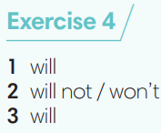
5. (4’) Complete the sentences using as … as or different from.  (Ex 5 – SB p.99)  - T calls a S to read the instruction then checks Ss’ understanding.  - T asks Ss to do exercise 5 individually before checking their answers with a partner.  - T calls some Ss to give their answers and corrects if needed.  - T gives feedback on Ss’ work. | 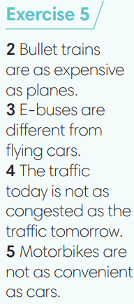
4. PRODUCTION (8’)
ACTIVITY 6:
* Aim: To practice writing a paragraph about the advantages and disadvantages of a means of transport.
* Content: Writing a paragraph.
* Outcome: To review three types of sentences in a paragraph.
* Organisation: T’s instruction.
Teacher’s & Student’s activities |  |  | Content
6. Write a paragraph (60-80words) about the advantages of travelling by motorcycle. You should include a topic sentence, supporting sentences and a concluding sentence.  (Ex 6 – SB p.99)  - T calls a S to read the instruction then checks Ss’ understanding.  - T brainstorms some advantages of travelling by motorcycle with the whole class.  - T asks Ss to write their paragraph individually.  - T walks around the class to correct any mistakes if needed.  - Ss check in pairs to find any mistakes.  - T invites some Ss to share their writing and other Ss comment. |  |  | 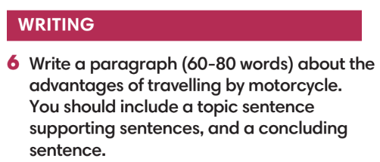
WRAP-UP & HOME WORK (3’)
T asks Ss to talk about what they have learned in the lesson.
- Review vocabulary and grammar of Unit 9.
* HOMEWORK
- Do exercises in the workbook page 85.

