Date of planning:  Date of teaching: | UNIT 2: FAMILY AND FRIENDS  Period 20: Grammar 2
I. OBJECTIVES:
By the end of the lesson students will be able to:
- use Present Simple and Present Continuous to talk about what usually happens and is happening around now.
1. Knowledge:
* Grammar:
- Identify the Present Simple and Present Continuous (rules and time expressions)
- Talk about what usually happens and is happening around now
2. Competence: Understand and use vocabulary about habits and routines, and understand the rules and time expression of present simple and present continuous, then do the tasks assigned in the textbook; use the correct tense of verbs to form a question about daily routines or things happening at the speaking time or in a period of time.
3. Quality/ behavior: To teach Ss to be hard-working and attentive in class. Ss have a positive attitude to working in groups, individual work, pair work, cooperative learning and working.
II. TEACHING AIDS:
- Teacher: Grade 7 textbook, Unit 2 (SB p. 24), laptop/computer connected to the Internet, loudspeaker, projector/TV, PPT slides…
- Students: Textbooks, studying equipment…
- Method: Active teach, T-WC; group works; individual ……
III. PROCEDURE:

1. WARM UP (5’)
* Aim:
- To create a positive classroom atmosphere to start a new lesson.
- To help Ss review the words of hobbies and interests.
* Content: Game: Tom & Jerry (with the simple present)
* Outcome: Ss use the correct form of the verb in the Present Simple tense and Present Continuous tense.
* Organisation: T, Ss ..….

Teacher’s & Student’s activities | Content
Extra activity 1: Tom & Jerry Game  - T asks Ss to prepare 3 letter cards A, B and C (T may ask Ss to prepare them before the lesson.)  - T explains the game rules then checks instructions.  - Ss join in the game individually.  - T corrects Ss if necessary.  - T tells students to talk more about interests and hobbies by asking two questions:  What do you like doing in your free time?  How often do you do these activities? | Game rules:  - Read the sentence  - Show the letter card A, B or C to give answers.  - 1 correct answer = 1 point.  - 1 wrong answer => Tom catches Jerry.
2. LEAD-IN (3’)
*Aim:
- To lead into the new lesson.
- To provide Ss with reasons for listening to the text in exercise 1 (SB p.24).
* Content: Ss answer the questions about the activities.
* Outcome: Get the right answers on time.
* Organisation: T_ Ss ..….

Teacher’s & Student’s activities | Content
Extra activity 2: See – think – wonder.  - T shows a picture on the slide then asks students four questions.  (1) What can you see in the picture?  (2) What is the girl doing?  - T sets a time limit for Ss’ quick discussion.  - Ss work in pairs to make guesses about the picture then give answers.  - T calls some Ss to give answers then checks with the whole class.  - T introduces Kim. “This is Kim. She is talking about her routines.” | 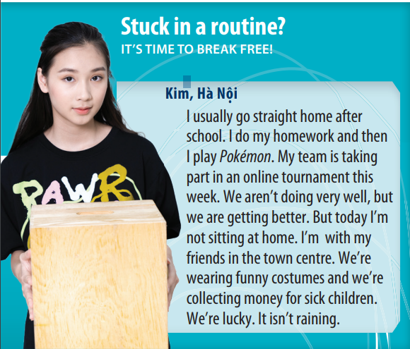
3. PRESENTATION (11’)
ACTIVITY 1 + 2:
*Aim:
- To present the grammar point in context.
- To lead into the next activity.
- To introduce to students the uses and time expressions of the Present Simple and
Present Continuous tense.
- To explain the grammar point for Ss.
* Content: To practice using the present simple and present continuous in context by
choosing the correct answer.
* Outcome: Practicing the use of the present simple and present continuous by writing
the correct form of the verbs.
* Organisation: T, Ss ..….
Teacher’s & Student’s activities |  |  | Content
1. (7’) Read the text and answer the questions.  (Exercise 1 – SB p24)  - T asks Ss to open their SB page 24, look at exercise 1.  - T calls a student to read the instruction then checks Ss’ understanding of it.  - T calls four students to read for questions.  - T tells Ss that they are going to read the text to find answers.  - Ss work individually, read and note down the answers to the given questions.  - T calls some Ss to give answers then shows the answers on the slide. |  |  | Answer keys:  1. Kim usually goes straight home,  does her homework and then plays  Pokémon.  2. No, they aren’t (but they’re getting  better).  3. Today she’s with her friends in the  town canter, collecting money for sick  children.
2. (4’) Find two more examples in the text for each rule below.  (Exercise 2 – SB p24)  - T goes through the Grammar box with students.  - T asks them which tense we use with adverbs of frequency such as always, usually, often (Present Simple).  - T asks them which tense we use to talk about something happening now, this week, today (Present Continuous).  - T reminds students that we use the Present Continuous not only for things happening exactly now but also for things happening around now, such as “I’m reading a great book.” (I’m not reading at this minute but I’m in the middle of reading the book.).  - T uses slide to show the grammar notes again.  - T asks Ss to look at exercise 2.  - T calls a student to read the instruction then checks Ss’ understanding of it.  - T asks Ss to work in groups of three to read the complete the activity.  - T calls groups to give answers then shows the answers on the slide to check as the whole class. |  |  | 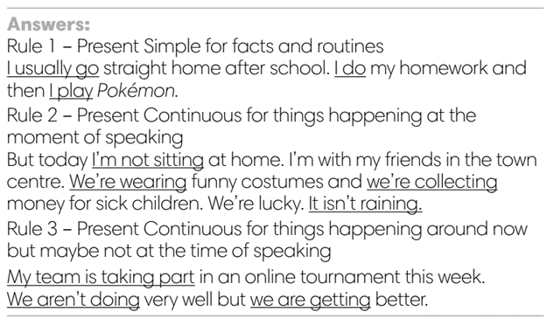
4. PRACTICE 1 (3’)
ACTIVITY 3:
* Aims: To help students identify the use of Present Simple and Present continuous.
* Content: Choose the correct option to complete the sentence.
* Outcome: Choose the option correctly in grammar and use present simple and present continuous to explain their options.
* Organisation: T, Ss, ….
Teacher’s & Student’s activities |  | Content
3. Choose the correct option  (Exercise 3 – SB p24)  - T elicits the example sentence with students.  - T asks them why the Present Continuous is the correct form to use (because it’s referring only to this semester, not as a permanent fact).  - T encourages students to discuss the other sentences in pairs,  to decide on the correct form and the reasons for this.  - T calls some students to share their answers.  - T corrects Ss’ pronunciation if any.  - T confirms the answers. |  | Answer keys:  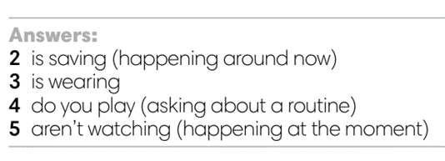
4. PRACTICE 2 (13’)
ACTIVITY 4:
* Aims: To help students practice making sentences in the Present Simple and Present Continuous.
* Content: Making correct sentences.
* Outcome: Making sentences describe someone’s usual life and what they’re doing by using present simple and present continuous.
* Organisation: T, Ss , Individual, Pair work, ….
Teacher’s & Student’s activities |  | Content
4. Make sentences with but to describe Paula’s usual life and what she’s doing now.  (Exercise 4 – SB p.24)  - T asks Ss to look at exercise 4.  - T calls a student to read the instruction then checks Ss’ understanding of it.  - T reminds students that we use but to link two contrasting ideas.  - T explains that in this instance, the contrast is between what usually happens and what is happening at the moment.  - T asks Ss to work in individually to write.  - Students write full sentences in their notebooks.  - T calls students to give answers then shows them on the slide to check as the whole class.  - T corrects Ss if any.  Further practice:  There are two more exercises from workbook.  - T uses the slides to lead the activity if time. |  | 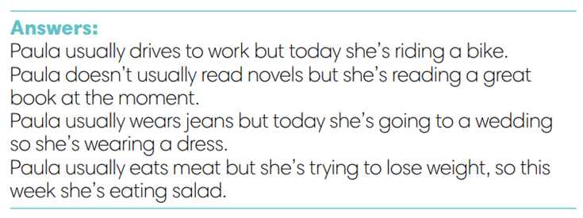
4. Production (7’)
ACTIVITY 5:
* Aims: To help students applying the vocabulary items and grammar points related to
the topic in communicating.
* Content: Do class survey; interview partners using the cues words.
* Outcome: Use vocabulary items and grammar points related to the topic to interview
partners.
* Organisation: T. Ss , Individual, Pair work, ….

Teacher’s & Student’s activities |  | Content
5. Class survey. Interview your classmates and write their names to complete the sentences.  (Exercise 5 – SB p.24)  - T asks Ss to look at exercise 5 (SB page 24).  - T calls a student to read the instructions then checks Ss’ understanding of it.  - T explains to the students that they are going to walk around  class and survey their friends.  - T elicits the questions that students may use to ask their friends.  - T models the activity in front of the class.  - T asks students to stand up and walk around the class and  interview other students to complete the sentences.  - T walk around to listen and notes down common mistakes for delayed feedback.  - T invites some students to report their sentences to the class.  - T asks the other students to give comments on their classmates’ performance.  - T gives feedback on Ss’ work. |  | 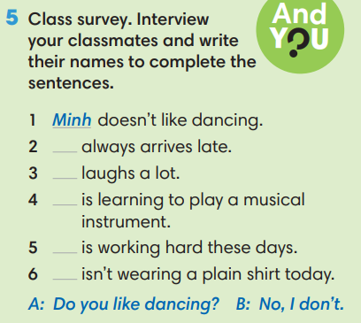
WRAP-UP & HOME WORK (3’)
- T asks Ss to talk about what they have learnt in the lesson.
- The present simple and present continuous tense: rules and time expressions
* HOME WORK
- Do exercises in the workbook page 19.
- Prepare for Lesson 2.5: Listening and vocabulary.
=========================

