Date of planning: 20/11/2022  Date of teaching: 22/11/2022 | UNIT 3: ANIMALS’ MAGIC  Period 34 Lesson 6: Speaking
I. OBJECTIVES:
By the end of the lesson student will be able to:
- make and respond to apologies.
1. Knowledge:
* Vocabulary: review some pet-related actions, learn some apologizing expressions.
* Grammar: make dialogue in the Present Simple with apologizing expressions.
2. Competence: Ss understand and use the vocabulary of apologizing expressions and other related topics to the lesson content, do the tasks assigned in the textbook. Listen for comprehension then make and response to some apologies.
3. Quality/ behavior: To teach Ss to be hard-working and attentive in class. Ss have a positive attitude to working in groups, individual work, pair work, cooperative learning and working.
II. TEACHING AIDS:
- Teacher: Grade 7 textbook, Unit 3 (SB p. 36, WB p.30), laptop/computer connected to the Internet, loudspeaker, projector/TV, PPT slides…
- Students: Text books, studying equipment…
- Method: Active teach, T-WC; group works; individual ……
III. PROCEDURE:
1. WARM UP + LEAD-IN (5’)
* Aim:
- To create a positive classroom atmosphere to start a new lesson.
- To review pet-related actions.
- To lead into the topic.
* Content: Play Mind-map to recall the vocabulary in previous lessons.
* Outcome: Students talk about pets by using the vocabulary in previous lessons.
* Organization of implementation: T- Ss
Teacher’s & Student’s activities |  | Content
Extra activity 1: Mind-map  - T writes the words “all things you need to do when you have a pet” on board and asks students to work in pairs/small group.  - Students discuss and list out all words they remember from previous lesson.  - Students use a mind-map to present their ideas.  - Teacher encourages students to stand up and share their answers in front of the class.  - Teachers explains that students find some of the warm-up words in the new lesson.  Unit 3 – Lesson 6: Speaking |  | 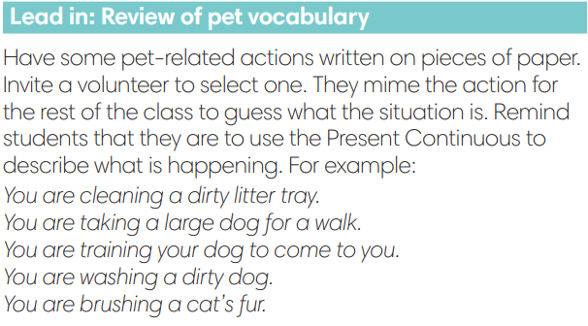
2. PRE-SPEAKING (20’)
ACTIVITY 1 + 2:
* Aim:
- To activate Ss’ prior knowledge of the topic.
- To start a class discussion
- To listen and identify specific information to answer the questions
- To read and identify specific information to answer the questions
- To introduce the Speaking Box
- To reinforce the apologizing expressions
- To classify statements of accepting and not accepting apologies.
* Content: Listen to the conversation to answer the questions about Kim and Nam.
* Outcome: Know about the apologizing expressions. Understand the conversation.
* Organisation: Teacher’s instructions…

Teacher’s & Student’s activities |  |  | Content
1. (5’) Look at the photos. How do you think Nam and Kim are feeling? Why? Listen and read to check your answers.  (Exercise 1 - SB p.36)  - Set the scene: T tells Ss to remember what happened in the dialogue of Unit 3 – Lesson 4.  - T has Ss work in pairs or small groups to discuss and find the answers for the questions.  - Ss do the tasks in pairs or in small groups.  - T calls some volunteer Ss to say aloud the possible answers.  - T plays the audio for Ss to check then confirms the answers.  - T provides information from unit 3-lesson 4: Nam was with Kim's dog, but it disappeared. He looked for it, but he doesn’t know where it is. |  |  | Answer keys:  Nam is feeling sad and embarrassed because he can’t find Kim’s dog.  Kim is feeling shocked and sad because Nam lost her dog.
2. (7’) Tick (v) the words and phrases from the dialogue.  (Exercise 2 – SB p.36)  - T asks students 2 questions then has Ss to discuss in pairs.  Who is doing the apologising?  Why do they feel they need to apologise?  - T confirms the answers:  - Nam is apologising for losing the dog.  - Kim is apologising for being rude.  - T asks Ss to look at exercise 2.  - T calls a student to read the instruction then checks Ss’ understanding of it.  - T sets a time limit for Ss to work in groups  - T calls groups to give answers to check as the whole class.  - T provides explanations and tell the whole class to read aloud the words and phrases from the Speaking Box together. |  |  | Answer keys:  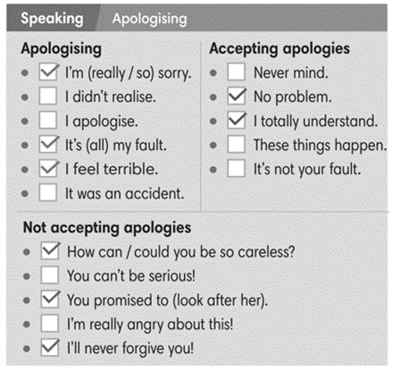
Extra activity 2 (3’): Minion Game  - T has Ss get ready for the game in team and explains the game rules.  - T uses Pptx slides to lead the games  - Ss in each team take turns to play.  - T rewards points for the winner then asks Ss to read the expressions aloud together. |  |  | Game rules:  - Read the sentence carefully.  - Choose A or B to fill in the blank.
3. (5’) Use the Speaking Box to complete the dialogues. Sometimes more than one answer is possible. Listen and check.  (Exercise 3 – SB p.36)  - T asks Ss to look at exercise 3.  - T calls a student to read the instruction then checks Ss’ understanding of it.  - T sets a time limit for Ss to work in groups  - T calls groups to give answers to check as the whole class. |  |  | Answer keys:  2. No problem.  3. It’s not your fault.  4. How can you be so careless?
3. WHILE-SPEAKING (10’)
ACTIVITY 3 + 4:
* Aim:
- To reinforce the apologizing expressions
- To practice the “apologizing” dialogue
* Content: Complete the conversations to express apologies.
* Outcome: Understand the use of apologizing expressions to communicate.
* Organisation: T, Ss ..….
Teacher’s & Student’s activities |  |  |  | Content
3. (5’) Act out the dialogue in exercise 3 – SB p.36 (Exercise 3 - SB p.23)  - T sets a limit for students to work in pairs to practice the dialogue as a role play.  - T invites some pairs of students to act out the roleplay in front of the class.  - Ss work in pair, practice the dialogue, then act out. |  |  |  | 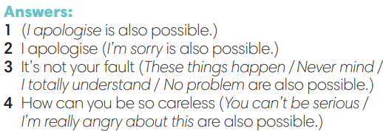
4. In pairs, follow the instructions. Use the  Speaking box to help you.  (Exercise 4 – SB p.36)  - T asks Ss to look at exercise 4.  - T calls a student to read the instruction then checks Ss’ understanding of it.  - T sets a time limit for Ss to work in pairs.  - Ss work in pairs to discuss on the given situation then build up the dialogue.  - T invites some pairs of students to perform in front of the class  - T provides corrections when needed. |  |  |  | 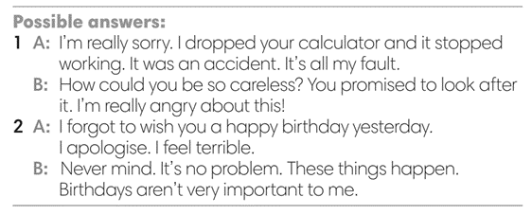
4. POST-SPEAKING (8’)
ACTIVITY 4:
*Aims: To help students applying the new language and skills related to the topic in communicating.
* Content: Express apologies to each other’s.
* Outcome: To practice apologizing expression by create a new situation and act out.
* Organisation : T, Ss .…

Teacher’s & Student’s activities | Content
Extra activity 3: Adaptation for Exercise 4 (SB p.36)  In pairs, create a new situation and act out.  - T tells student to look at the speaking box in their student book again and prepare for the task.  - T gives students time to think about what they are going to say in their roleplays.  - T encourages stronger students to introduce a situation as an example for the whole class, e.g. You lost your friend’s toy. You go home late.  - Students work in the same pairs from the last activity and practice their role plays, focus on using the correct intonation.  - Teacher invites pairs to act out their roleplays in front of the class. | 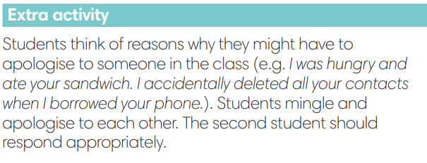
WRAP-UP & HOME WORK (2’)
- T asks Ss to talk about what they have learnt in the lesson.
- Apologizing expressions
* HOME WORK
- Do exercises in the workbook page 30.
- Prepare for Lesson 3.7: Writing.

