Date of planning: 20/11/2022  Date of teaching: 26/11/2022 | UNIT 3: ANIMALS’ MAGIC  Period 36: Lesson 8: Vocabulary in Action and Pronunciation
I. OBJECTIVES:
By the end of the lesson student will be able to:
1. Knowledge:
* Vocabulary: review vocabulary about animals, adjectives, looking after pets
- phrasal verbs of pet-looking activities
- word friends and word family
* Pronunciation: Listen and identify the rhyming words
2. Competence: Students develop communication skills, and creativity; be collaborative and supportive in pair work, and teamwork; actively join in class activities.
3. Quality/ behavior: To teach Ss the love of talking about relating topics of unit 3 and using word friends or phrasal verbs in pair work or group work, and develop self-study skills. Ss have a good attitude to working in groups, individual work, pairwork, cooperative learning, and working
II. TEACHING AIDS:
- Teacher: Grade 7 textbook, Unit 3 (SB p.38), laptop/computer connected to the Internet, loudspeaker, projector/TV, PPT slides… .
- Students: Text books, studying equipment…
- Method: Active teach, T-WC; group works; individual ……
III. PROCEDURE:
1. WARM UP + LEAD-IN (5’)
*Aims:
- To create an active atmosphere in the class before the lesson.
- To lead into the new lesson.
* Content: Game: NAME 3 THINGS CHALLENGE (animals)
* Outcome: Students say words relating to the given topic quickly.
* Organisation: Teacher’s instructions…
Teacher’s & Student’s activities | Content
Extra activity 1: NAME 3 THINGS CHALLENGE  * Teacher asks students to spend 1 minutes to quickly review all vocabulary they have learnt in Unit 3 before they play a warm-up game.  - T tells students that they are going to play a game called NAME 3 THINGS CHALLENGE  - T explains the game rules then checks instructions.  - Teacher uses the slides to show the challenge  - Ss join in the game pairs or in small groups.  - Teacher listens to the Ss answers and calls several Ss to check for the whole class.  - T tells Ss that they can remember better with Glossary Table and asks Ss to open their Student Book page 38 – Exercise 1. | Game rules:  - Choose a number to get the challenge  - Read the topic word  - Say 3 words relating to that topic quickly.
2. REVIEW VOCABULARY (18’)
(GLOSSARY TALBE)
ACTIVITY 1 + 2 + 3:
*Aim:
- To introduce the glossary and its uses.
- To give further practice in making sentences using the Glossary.
* Content: Revise what they have learnt during the unit. Glossary and its uses.
* Outcome: Remember the new words and animals’ name.
* Organisation : Teacher’s instructions…
Teacher’s & Student’s activities | Content
1. (7’) In pairs, say the names of there animals that you think are:  1. quiet  2. noisy  3. dangerous  4. cute  5. lively  (Exercise 1 – Student Book page 38)  - Teacher introduces the Glossary Table.  - T asks Ss to look at exercise 1 in student book page 38  - T has students use the glossary to find the words which belong to the correct category  - T asks students to work in pairs and quickly do the task.  - T allows students to peer check first.  - T checks and confirms the answers.  The answers can be variety depends on Ss’ choice. | 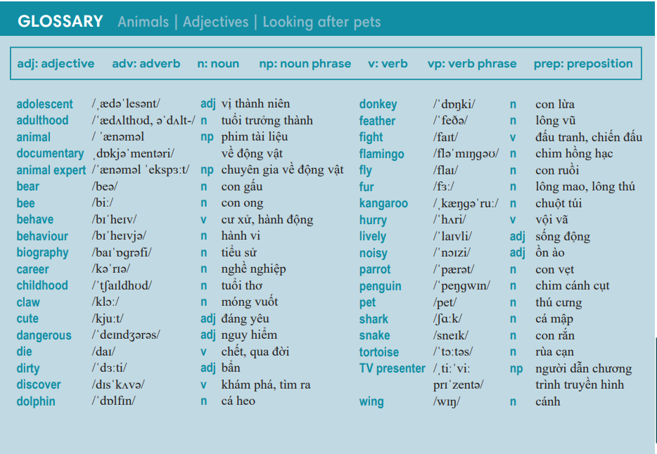
2. (6’) Complete the sentences with the prepositions below.  In pairs, say if you agree with the statements or not.  (Exercise 2 – Student Book page 38)  - T asks students to complete the sentences with suitable prepositions  - T asks students to work individually and check in pairs.  - T invites students to share their answers.  - T confirms the correct answers.  TIME TO TALK:  - Ss work in pairs to share if they agree or disagree to the statements in the exercise. | Answer key:  2. after / 3. for / 4. to / 5. for
3. (5’) Complete the sentences with the correct form of the word in bold.  (Exercise 3 – Student Book page 38)  - T asks Ss to open their SB page 38, look at exercise 3.  - T calls a student to read the instruction then checks Ss’ understanding of it.  - T gives students a time limit to work individually.  - T allows Ss to share their answers massively before checking the final ones as the whole class.  - T provides the meanings, pronunciations of the words in the exercise  Childhood / behaviour / adolescence / presenter  - T has students pronounce the words in pairs. | Answer key:  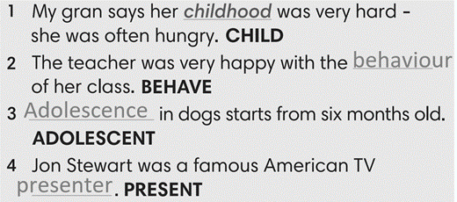
3. PRONUNCIATION (19’)
3.1. Presentation (13’)
ACTIVITY 4:
* Aims:
- To present the list of rhyming words
- To help students identify the rhyming words
- To help students listen and identify rhyming words in pairs.
* Content: Do exercises to practice pronunciation.
* Outcome: Say the rhyming words correctly.
* Organisation: Teacher’s instructions…

Teacher’s & Student’s activities | Content
4. (7’) Complete the sentences. Use the words below that rhyme with the underlined words. There are two extra words.  (Exercise 4 – SB p38)  - Teacher uses the slides to lead the activity  - T calls a student to read the instruction then checks Ss’ understanding of it.  - T gives students a time limit to work individually.  - T allows Ss to share their answers massively before checking the final ones as the whole class.  TIME TO SAY  - T have students say the rhyming words in pairs/ group | Answer keys:  2- wing, 3-hurry, 4-snake, 5-fly, 6-zoo, 7-bear
Extra activity 2 (6’): Defeat The Goalkeeper Game  - T introduces the game and explains the rules.  - T calls some students to read out the words first.  - T plays the audio tracks for them to listen choose.  - T invites some students to share their answers.  - T confirms the answer using the slide and rewards points for the winner team. | Game rules:  - Read the questions carefully.  - Choose the answer A or B to defeat the goalkeeper.  - 1 correct answer = 1 point.
3.2. Practice (6’)
* Aims: To enhance the rhyming words
* Content: Play Phonic Game to practice pronunciation.
* Outcome: Say the words with the correct rhymes.
* Organisation : Teacher’s instructions…

Teacher’s & Student’s activities | Content
Extra activity 3: Phonics Game  - T has Ss to play the game in pairs, explains the rules.  - T sets a time for students to play in pairs, walks around and provides support when needed. | Game rules:  - Student A says a word (from the phonics list)  - Student B says a word that rhymes with Student A’s word  - Swap the role.
WRAP-UP & HOME WORK (3’)
- Teacher asks students to talk about what they have learnt in the lesson.
- Use a Glossary to review
- Identify rhyming words
* HOME WORK
- Find more rhyming words
- Prepare for Unit 3 – Lesson 9: Revision

