Date of planning: 27/11/2022  Date of teaching: 3/12/2022 | UNIT 4: HEALTH AND FITNESS  Period 39: Lesson 1: Vocabulary
I. OBJECTIVES:
By the end of the lesson, students will be able to:
- have an overview of the topic “Health and Fitness”.
- use vocabulary and grammar points to talk about the body and keeping fit.
1. Knowledge:
*Vocabulary: an understanding of the meaning of key words or word collocations below:
Body parts | ankle, elbow, eyebrows, finger, knee, lips, neck, shoulder, toes, stomach, skin, heart, brain
Activities to keep fit | play rugby/ football/baseball, do exercise, go to the gym, do weight training, go running, do yoga, have fitness classes, go swimming

*Grammar: expressions to talk about personal routine of keeping fit.
2. Competence:
To know the meaning of the keywords used to talk about body parts and keep – fit activities, and understand the main grammatical points, then do the tasks assigned in the textbook. To use the targeted language to practice talking about body and keeping fit.
3. Quality/Behavior: To teach Ss to be hard-working and attentive in class. Ss have a positive attitude to working in groups, individual work, pair work, cooperative learning and working.
II. TEACHING AIDS:
- Teacher: Grade 7 textbook, Unit 4 (SB p.40-41, WB p.33-34), laptop/computer connected to the Internet, loudspeaker, projector/TV, PPT slides…
- Students: Text books, studying equipment…
- Method: Active teach, T-WC; group works; individual ……
III. PROCEDURE:
1. WARM UP (3’)
* Aims:
- To activate Ss’ prior knowledge and get students involved in the lesson.
- To set the context for introducing new words.
* Content: Play Super Eyes game to get students involved in the lesson and to set the context for the lesson.
* Outcome: Students name the body’s parts correctly.
* Organisation: Teacher’s instructions…

Teacher’s & Student’s activities | Content
Extra activity 1: Super Eyes game  - T explains the game rules then checks instructions.  - T uses the PPT slides to lead the game.  - T tells students that they are learning more words of body parts in today lesson.  - T sets the context for the lesson: Write the title on the board Unit 4: Health and fitness / Lesson 4.1: Vocabulary  - T asks Ss to name some more words of body parts they’ve already known. | Game rules:  - Look at the pictures.  - Remember as many body parts as you can  - Recall the words you remember  - 1 correct words = 1 point.
2. PRESENTATION 1 (8’)
VOCABULARY
ACTIVITY 1:
* Aims:
- To reinforce the words of body parts that students have already known.
- To teach more new words
- To lead in to the next activitiy.
* Content: Some brief notes; Some things body parts.
* Outcome: Know new words about body parts.
* Organisation: Teacher’s instructions….
Teacher’s & Student’s activities |  | Content
1. Match the words below with the parts of the body 1-9 in the photos. Listen and check.  (Exercise 1 - SBp40)  - T asks Ss to open their SB page 40, look at exercise 1.  - T calls a student to read the instruction then checks Ss’ understanding of it.  - T elicits the meaning of words in the Vocabulary Box and quickly checks Ss’ understanding of vocabulary by asking them to look at the picture in SB and say all the body parts they see.  - Then, T asks students to look at exercise 1 and complete.  - Ss can work in pairs or small groups to finish the task.  - T plays the audio for students to check, T may pause the audio for students to listen and repeat if necessary. |  | Answer keys:  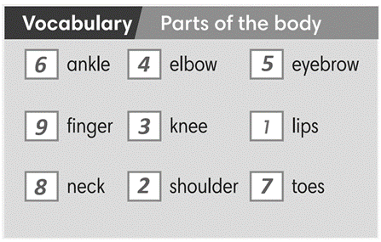
3. PRESENTATION 2 (5’)
ACTIVITY 2:
* Aims: To introduce more new words in a context
* Content: Some brief notes; Some facts about human body.
* Outcome: Know new words about human body and understand the functions of body parts.
* Organisation: Teacher’s instructions….
Teacher’s & Student’s activities | Content
2. Read the text below and follow the instructions.  (Exercise 2 - SBp41)  1. Listen and repeat the highlighted words.  How do you say them in your language  - T asks students to look at the facts on page 41, listen and  repeat the highlighted words.  - Teacher elicits the meaning of 4 new words of body part and may provide further explanations of the words in Vietnamese.  - Ss to look at the slides, slowly displays the vocabulary  - T tells Ss to say the words one by one  - Ss join the activity as the whole class.  2. Which facts do you find interesting?  - T asks Ss to read the fun facts again and put a tick next to the facts they find interesting.  - T encourages Ss to share with their partners.  - T invites some volunteers to express their interests in front of the whole class.  - T checks pronunciation if needed.  - T shows slides of all vocabulary again for Ss to review quickly with focus on the IPA of the words. | 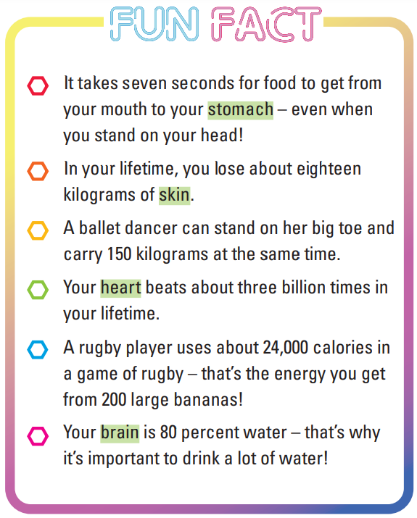
4. PRACTICE 1 (9’)
ACTIVITY 3:
* Aims:
- To provide students with chances to practice pronouncing new words
- To help students use the new vocabulary in context
* Content: Some brief notes about the exercise; some keywords about body parts; some note about pronunciation.
* Outcome: Have a vocabulary about clothes; know how to talk about body parts and preferences.
* Organisation: Teacher’s instructions….
Teacher’s & Student’s activities | Content
3. (5’) Complete the sentences with the correct form of the body parts.  (Exercise 3 – SB p.41)  - T asks Ss to look at exercise 3 (SB page 41).  - T calls a student to read the instruction then checks Ss’ understanding of it.  - T sets a time limit and asks Ss to work in groups of three to complete the exercise.  - T calls groups to give answers then checks as the whole class.  - T drills the vocabulary and corrects Ss’ pronunciation if any. | Answer keys:  (2) heart (3) Hair (4) skin (5) knees
Extra activity 2 (4’): Choose the correct option  (Adapted from exercise 2 – WB p.33)  - T asks Ss to look at excersise 2 (WB page 33).  - T calls a student to read the instruction then checks Ss’ understanding of it.  - T sets a time limit and asks Ss to work in pairs to complete the exercise.  - T calls students to give answers then checks as the whole class.  - T drills the vocabulary and corrects Ss’ pronunciation if any. | Answer keys:  (1) brain (2) skin (3) heart  (4) muscles (5) beard (6) stomach
4. PRACTICE 2 (8’)
ACTIVITY 4:
* Aims:
- To provide more words related to the topic
- To help Ss use the new vocabluary in collocations.
- To practice the vocabulary in present simple tense using adverbs of frequency
* Content: Some brief notes about the exercise; some keywords about fitness activities.
* Outcome: Have a vocabulary about fitness activities; know how to talk about fitness routine.
* Organisation: Teacher’s instructions….
Teacher’s & Student’s activities
4. (4’) Listen and complete the sentences with the words below.  (Exercise 4 – SB p.4)  - T asks Ss to look at excersise 4 (SB page 41).  - T calls a student to read the instruction then checks Ss’ understanding of it.  - T asks Ss to read the given words aloud, checks their understanding of the words.  - T plays the audio for the whole class to listen and do the exercise individually  - T sets a time limit and asks Ss to work in groups of four to compare their answer and complete the exercise together.  - T calls groups to give answers then checks as the whole class.  - T corrects Ss’ pronunciation if any.  - T encourages Ss to say more of activities to keep fit they know. | Answer keys:  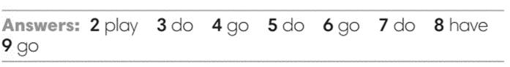
Extra activity 3 (4’): Match the parts of the sentences.  (Adapted from exercise 5 – WB p. 34)  - T asks students to look at their WB p.34 – Exercises 5  - T calls a student to read the instruction then checks Ss’ understanding of it.  - T asks Ss to work in pair to complete the exercise  - T calls volunteers to read aloud the answers.  - Ss raise their hand to give answers.  - T confirms the answers, corrects Ss’ pronunciation if any. | Answer keys:  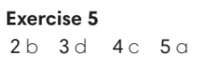
4. PRODUCTION (7’)
ACTIVITY 5:
* Aims: To help Ss practice applying the vocabulary items and grammar points related to the topic in speaking.
* Content: Ss play The truth game to talk about their activities to keep fit.
* Outcome: Ss talk about activities to keep fit using vocabulary and grammar points.
* Organisation: Teacher’s instructions…..
Teacher’s & Student’s activities | Content
5. Let’s play the truth game. Work in pairs. Use the exercise 4 to help you.  (Exercise 5 – SB p.41)  - T asks Ss to look at excersise 5 (SB page 41).  - T calls a student to read the instruction then checks Ss’ understanding of it.  - T asks students to work individually to write the true sentences about keeping fit.  - T display the slide with WAYS TO KEEP FIT content and model sentences:  Example:  I don’t do exercise at home, but I go to the gym once a week.  TIME TO TALK  - T sets a time limit and ask students to share their truth with a partner.  - Then T claps hands, asks Ss to change the partners.  - Ss swap and share their truth to as many friends as they can.  - T moves around to support, takes note the common issues that need to be discussed later.  - T announces when the sharing time finishes and gives feedback to students. | 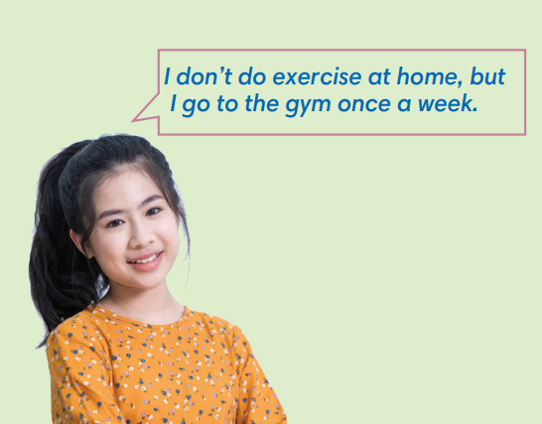

WRAP-UP & HOME WORK (3’)
- T asks Ss to talk about what they have learnt in the lesson.
- Vocabulary of body parts and keep fit activities.
- Grammar points: Present simple and adverbs of frequency to talk about keep fit activities
* HOME WORK
- Do exercises in the workbook page 33-34.
- Prepare for Lesson 2: Grammar 1.

*************************************************************************

