Date of planning: 25/12/2022  Date of teaching: 26/12/2022 | Period 49: Review
I. OBJECTIVES:
By the end of the lesson, Ss are able to:
1. Knowledge:
* Vocabulary: revise culture, cultural activities, like and dislike, age groups ,news, and entertaintment, words related to clothes, accessories, personalities, and time expressions.
* Grammar: review present simple, present continuous tense to describe people, talk about after school activities, give and respond to news.
2. Competence: Ss understand and use the vocabulary of the unit1+ 2, do the tasks assigned in the textbook. Participate in a guided conversation to give and respond to news using given information.
3. Quality/ behavior : To teach Ss to be hard-working and attentive in class. Ss have a positive attitude to working in groups, individual work, pair work, cooperative learning and working.
II. TEACHING AIDS:
- Teacher: Grade 7 textbook, Unit 1+2 (SB p. 29, WB p.23), laptop/computer connected to the Internet, loudspeaker, projector/TV, PPT slides…
- Students : Text books, studying equipment….
- Method: Active teach, T-WC; group works; individual ……
III. PROCEDURE:

- WARM-UP (4’)

*Aims:
- To create a positive classroom atmosphere to start a new lesson.
- To lead into the review lesson.
* Content: Game: SUPER EYES
* Outcome: Ss understand that they are going to review Unit 2.
* Organisation: Teacher’s instructions…
Teacher’s & Student’s activities | Content
Extra activity 1: SUPER EYES  - Set the scene: T asks students to do quick exercises for eyes such as look up and down, look left and right, row the eyes  - T tells students that they are going to play a game called SUPER EYES  - T explains the game rules then checks instructions.  - Teacher uses the slides to show the collages  - Ss join in the game pairs or in small groups.  - Teacher shows the collage again with displayed answers to check for the whole class.  - T tells Ss that they are going to review Unit 2. | Game rules:  - Look carefully at a collage of different small pictures  - The collage will disappear in a few seconds  - Recall as many words about the collage as you can remember.
- REVIEW VOCABULARY (17’)

ACTIVITY 1 + 2 + 3:
* Aims:
- To help students reviews topic words and word friends from the unit
- To review vocabulary with critical thinking
- To review vocabulary in context
* Content: Do the exercise to revise the vocabulary of Unit 1.
* Outcome: Understand the vocabulary to do the exercise correctly.
* Organisation : Teacher’s instructions….
Teacher’s & Student’s activities | Content
Extra activity 2: (5’) SUPER MIND  - T tells students to open the Glossary box in student book page 28  - T introduce the SUPER MIND game and rules  - T shows the slides of the game  - Ss take turns to choose the numbers for their teams.  - Ss discuss and list out all words related to the topic they get.  - T calls some Ss to give answers and confirms the winner. | How to play:  - Play in team  - Choose a number to open a block  - Read the topic word  - Write as many words related to the topic as you can  - The faster finisher gets points
1. (3’) Choose the odd one out  (Exercise 1 – Student Book page 29)  - T asks Ss to look at exercise 1 in student book page 29  - T calls a student to read the instruction then checks Ss’ understanding of it.  - T asks Ss to work in pairs to read then complete the activity.  - T encourages students to give the reason for their answer.  - T checks as the whole class. | Answer keys:  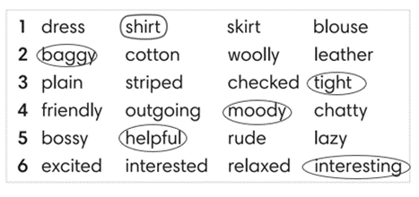
2. (6’) Complete the second sentence so that it means the same as the first one. In pairs, say if the sentences are true for you.  (Exercise 2 – Student Book page 29)  - T asks Ss to look at exercise 2 in student book page 29  - T calls a student to read the instruction then checks Ss’ understanding of it.  - T asks Ss to work in pairs to read then complete the activity.  - Ss work in pair to complete the task and compare the answers.  - T checks as the whole class.  Exercise 2 - Time to talk:  - T asks Ss to work in pairs to share their facts.  - Ss work in pairs to say which statements are true for them. | Answer keys:  2. is boring / 3. annoyed / 4. shocking / 5. Relaxed  Example:  Number 1 is true for me. I’m not into fashion.  Number 4 is not true for me.
3. (3’) Complete Word Friend in the text. Use the words in correct form.  (Exercise 3 – Student Book page 29)  - T asks Ss to look at exercise 3 in student book page 29  - T calls a student to read the instruction then checks Ss’ understanding of it.  - T asks Ss to work in pairs to read then complete the activity.  - Ss work in pair to complete the task and compare the answers.  - T checks as the whole class. | Answer keys:  2. to 5. brushing  3. getting 6. lose  4. annoyed 7. get
3. REVIEW GRAMMAR ( 24’)
ACTIVITY 4 + 5 + 6:
*Aim:
- To help students revise the form and use of the present simple, present continuous. Preposition of time
- To help students practice the present simple and present continuous
- To help students practice the present simple and time expression in a communicative activity
- To help student practice speaking skill in a task: give and respond to news
* Content: Use the present simple and present continuous to complete the exercises.
* Outcome: Use the present simple and present continuous for communication and writing.
* Organisation : Teacher’s instructions….
Teacher’s & Student’s activities | Content
Extra activity 3: (3’) Read the grammar boxes and review the grammar points.  - T asks Ss to look at the grammar box and read the example.  - T shows slides for detail review grammar  - Ss read the review content together before they do some grammar tasks. | 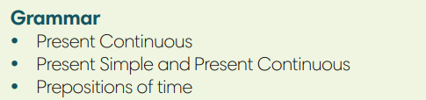
4. (5’) Complete the sentences with Present Simple or Present Continuous form of verbs in brackets.  (Exercise 4 – Student Book page 29)  - T asks Ss to look at exercise 4 in student book page 29  - T calls a student to read the instruction then checks Ss’ understanding of it.  - T asks Ss to work in pairs to read then complete the activity.  - Ss work in pairs to complete the task and compare the answers.  - T checks as the whole class. | Answer keys:  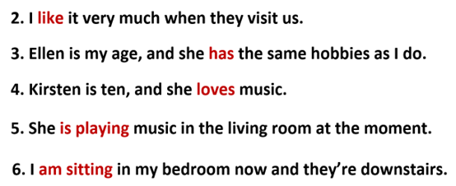
5. (8’) Write answers to the questions.  Use at, in or on with a time expression. Then compare with a partner.  (Exercise 5 – Student Book page 29)  Step 1: Time to write  - T asks Ss to look at exercise 5 in student book page 29  - T calls a student to read the instruction then checks Ss’ understanding of it.  - T elicits an example.  - T sets a time limit for Ss to write sentences  - Ss write their sentences in their notebooks.  Step 2: Time to pair  - T asks Ss to work in pairs and share their sentences by asking and answering.  - T calls a pair of strong students to demonstrate the dialogue in front of the class.  - Ss work in pairs to practice asking and answering.  - T encourages some pairs to roleplay the dialogue in front of the class. | 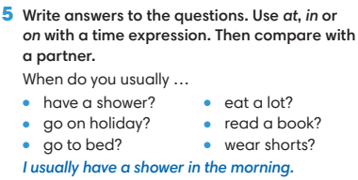
6. (8’) Work in pairs. Student A, use the information below to give and respond to news. Student B, look at page 102.  (Exercise 6 - Student Book page 29)  Student A  1. Greet Student B and ask what’s new in his / her life.  2. Listen and respond to Student B’s news  *you’re learning how to make webpages  *your computer isn’t working at the moment  - T asks Ss to look at exercise 6.  - T calls a student to read the instruction then checks Ss’ understanding of it.  - T asks Ss to work in pairs to prepare for their dialogues  - T sets a time limit and walk around as a monitor while Ss are discussing.  - Ss work in pairs to practice the speaking task  - T moves around and takes notes for any issues that need improving from students work.  - T encourages some strong students to role-play their dialogues in front of the class.  - T gives some general feedback for Ss’ performances. | 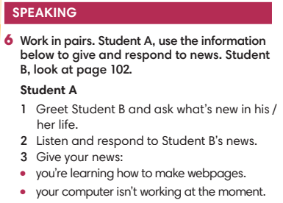
WRAP-UP & HOME WORK ( 2’)
- T asks Ss to talk about what they have learnt in the lesson.
- Review Unit 2 vocabulary and grammar.
- Write a personal introduction for a webpage.
* HOMEWORK
- Do exercises in the workbook page 23
- Prepare for revision for the first semester test.
************************************************************************

